Reflections on the ENFP-T Personality Type
1.0 ENFP-T Analysis
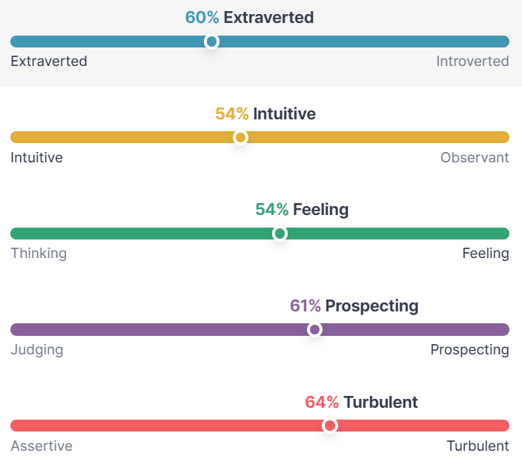
Upon completing the MBTI assessment, my personality was identified as ENFP-T, suggesting that I am likely to draw energy from social interactions and tend to express my enthusiasm and excitement outwardly. Thus, I consider extroversion to be the defining characteristic of my personality, in other words, it is the extraversion dimension within the Big Five Personality Traits we studied.
Figure 1 ENFP-T Personality Traits
2.0 An Appropriate Example
During my university studies, a team project experience vividly showcased my extroverted traits. A pivotal moment that exemplified this trait occurred on February 2, 2024, during the American College Mathematical Modeling Competition, where I led a diverse team tasked with completing a report within a tight four-day deadline. However, due to a lack of effective communication and collaboration, the project's progress was sluggish, and the cooperation among team members seemed somewhat rigid. As the team leader, I harnessed my extraversion to take on the role of communicator and coordinator. I initiated a brief team meeting to clarify each individual's responsibilities and expectations, ensuring that every member was aware of their tasks and deadlines. Furthermore, I encouraged team members to actively exchange ideas, fostering innovative thinking through open discussions, which not only promoted teamwork but also enhanced problem-solving efficiency.

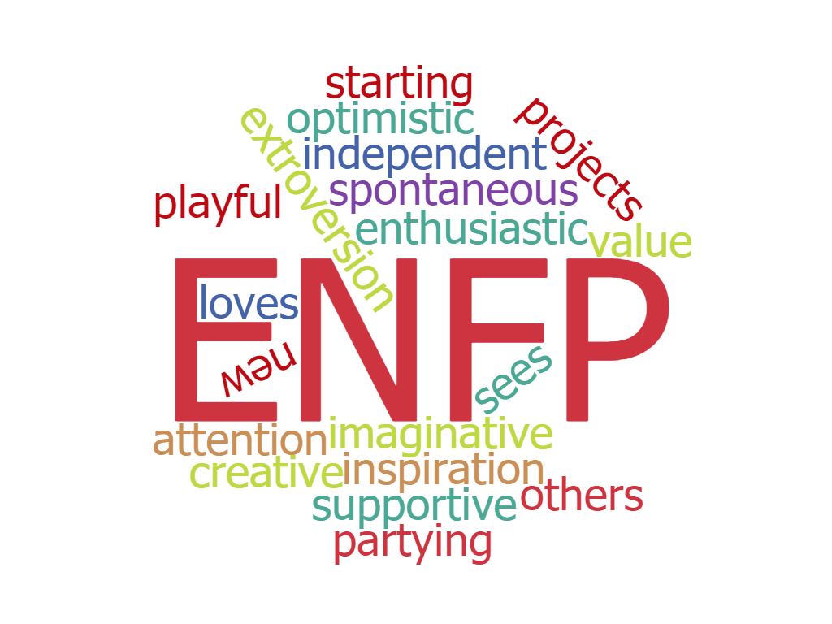
3.0 Personality and Organisational Behaviour
Figure 2 ENFP – Extroversion. Intuition. Feeling. Perceiving.
This experience was significant because it made me realize the importance of extroversion in team collaboration. My extroversion enabled me to proactively communicate with team members, establish connections, and propel the project forward. According to Zhang et al. (2022), individuals with high extroversion often play an active social role in teams, promoting teamwork through effective communication and leadership skills. Additionally, the conscientiousness aspect of my personality drove me to be responsible for the details of my tasks. As the modeller, constructed the appropriate mathematical framework, I also assisted the programmer in completing his portion of the code. Gill et al. (2020) state that highly conscientious individuals tend to focus on completing tasks and achieving goals, playing a crucial role in team collaboration by positively impacting the team's success through their actions. In this team project experience, the combination of my extroversion and conscientiousness motivated and guided our team to efficiently complete the report before the tight deadline and won us the Honorable Mention in the competition.
4.0 Future and Written Reflection
My short-term goal is to take on the role of a project leader in the upcoming College Student Innovation Training Program, leading a diverse team to develop a quantifiable solution to optimize urban traffic flow management. With insights and self-reflection based on the MBTI assessment, I have gained a deeper understanding of my personality. This self-awareness will aid in my continuous personal growth and progress, aligning with the objectives of this task and deepening the comprehension of my personality and its impact on organizational behaviour. Moving forward, I will continue to utilize my extroversion and conscientiousness to become a leader in the academic field who can inspire team potential and drive project success.
(499 words)
References
16 Personalities. (2024). ENFP-T Personality Traits [Infographic]. 16 Personalities. https://www.16personalities.com/enfp-personality
Gill, C., Metz, I., Tekleab, A. G., & Williamson, I. O. (2020). The combined role of conscientiousness, social networks, and gender diversity in explaining individual performance in self-managed teams. Journal of Business Research, 106, 250–260. https://doi.org/10.1016/j.jbusres.2018.09.003
Oliwia, M. (2016). ENFP – Extroversion. Intuition. Feeling. Perceiving. [Infographic]. Introverted Ultimate. https://introverted-ultimate.com/introverts-vs-extroverts-16-personality-types/
Zhang, J., Yin, K., Li, S., & Fan, M. (2022). Leader extraversion and team performance: A moderated mediation model. PloS One, 17(12), e0278769–e0278769. https://doi.org/10.1371/journal.pone.0278769

